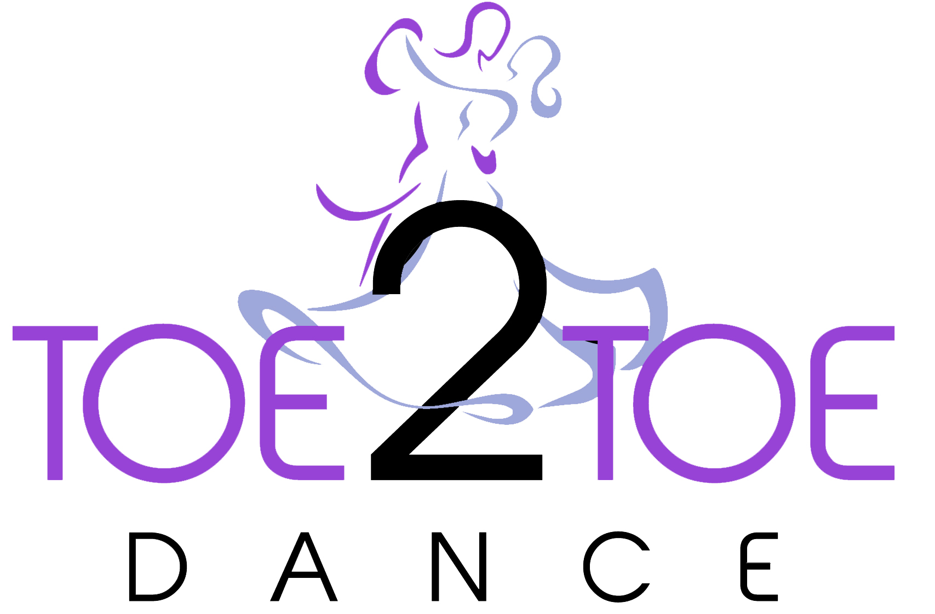

Come Dancing with Poppyscotland 2023
In partnership with Toe2Toe Dance

Please complete the form and email it to m.jamieson@poppyscotland.org.uk or drop it into Toe 2 Toe Dance, Mercury House, Wyvis Place, Inverness l, IV3 8DR

Personal Details
Title: First Name: Surname:
Address:

Postcode:
Telephone Numbers Home:
Mobile:
Email Address:
Age: Occupation:

Additional Questions
Why do you want to take part in Come Dancing with Poppyscotland?

Do you have any Military connections? Yes/No
If yes, please comment below: -

Do you have dance experience? Yes/No
If yes, please comment below: -

If successful, you will be paired with a dancer. In order to pair you with the correct partner can you please provide the following details: -
Height: Feet Inches
Build, please circle:
Small
Medium
Large

If successful, you will be asked to fundraise a minimum of £750 for Poppyscotland. Can you tell us your ideas in achieving this? (We will of course help you every step of the way)

If successful you will require a corporate sponsor who is willing to donate £350 towards the costs of outfits, shoes etc. Can you advise if you have this in place or who you would approach?

Thank you for taking time to complete the application. Poppyscotland will be in contact after the closing date which is Sunday 31st July 2020.

Privacy Statement
At Poppyscotland we take your privacy seriously and we will only use the information you have provided on this form to process your application.

We will use the contact details you have provided to process your application and in order to provide a reply. We will not share your data and promise to keep your personal information safe and secure.

We will hold your personal data until or until you withdraw your consent.

For more information about our Privacy Promise please visit our website www.poppyscotland.org.uk/contact-us/contact-form

